Minutes of the Annual General Meeting of Prebbleton Community Association held on 21st November 2023 at the Cottage

Present:
Graeme Gemmill, Angela Hart, Averil and Graham Carpenter, Alastair Joyce, Malcolm Lyall, David Martin, Angela Jones, Chris White, Sandra and Lindsay Serra, Peter Grundy, Daphne McAven, Alison and Cyril Fifield, Belinda Jeursen, Penny Webster, Jane Elms, Adrienne Gemmill, Karen Frater and Deanne Field.
Apologies:
Derham McAven, Cathy Smith, Nicola Cherry, Michael Jones, Sue and John Sheaf.

Apologies accepted, moved Graeme G, seconded Averil C.

Minutes of the AGM 2022:
Accepted as a true and correct record, moved Graeme G, seconded Angela H.

Minutes of the SGM held just prior to the AGM 2022 to amend the Constitution:
Accepted as a true and correct record, moved Graeme G, seconded Graham C.

Minutes of the SGM held to amend the PCA signatories subsequent to the 2022 AGM:
Accepted aș a true and correct record, moved Graeme G, seconded Alastair J.

Matters arising from the 2022 AGM minutes:
It was stated at the AGM that the Cell Tower Fund was ring-fenced for the benefit of Prebbleton but we found out during this year that the funds are actually sitting in a Selwyn District Council Township Fund for the benefit of Selwyn generally.

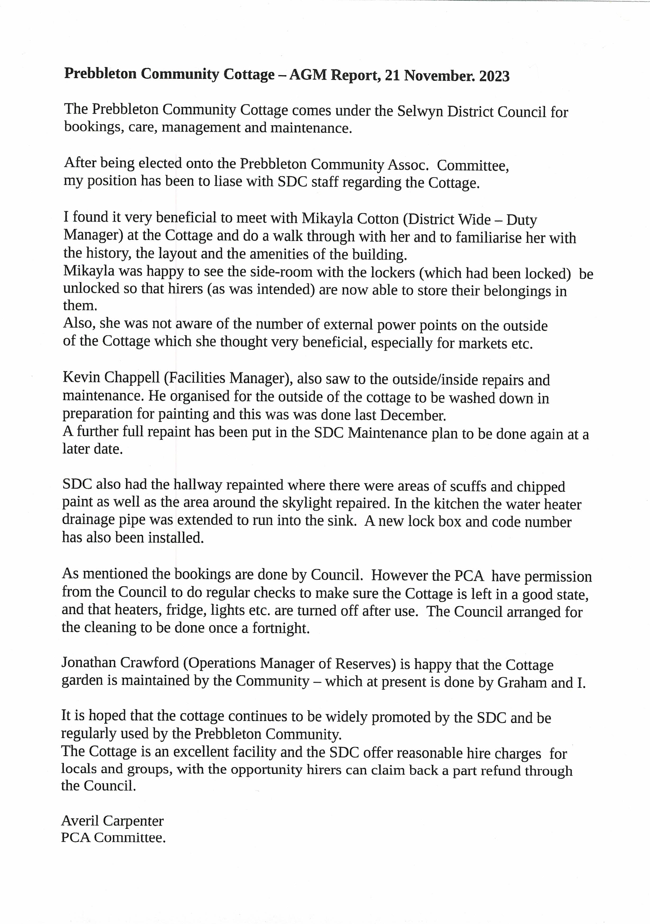

PCA Chairperson’s Report:

Our new Committee pulled out all stops to get the Christmas Carols and Evening Market Event organised.
Special thanks to Gary Miller, Geoff Gilfedder and Committee members for making the Event possible.
With a small attendance to our February monthly market; the cancellation due to weather of the March monthly market and notification that Rolleston were no longer running markets; the viability of our market when not attached to an Event came into question.
Our April monthly market linked to the Giant Pumpkin Event was a great success and enhanced our belief that an Event with Market Stalls was the way to go. Thanks to Marcus Peters for bringing his enthusiasm for this event.
The ANZAC Commemoration was coordinated by PCA with support from the Prebbleton School, Prebbleton Hall Committee, Prebbleton Heritage, SDC and Templeton RSA.
Our Matariki Event held at the School was another memorable Event with special thanks to the school and their kapa haka group; Angela Jones and Jane Elms and our Committee; as well as willing helpers from the Prebbleton community.
To bring events to the attention of local residents we have produced the Prebbleton Life Newsletter initially bi-monthly and currently monthly in both digital and printed form.
Huge thanks to Peter Grundy of Resolv Advertising & Design Ltd, Dave Martin our Editor, Linda Martin and Natalie Mclean who have donated hours of their time and skills to produce such a high quality product. Thanks also to all who have contributed articles and information for us to use. Keep the up-to-date information stream coming.
PCA has liaised with SDC regarding Plan Change consents affecting our residents as well as the roading and beautification issues as they have arisen.
Secretary, Angela Hart has worked arduously getting Grants and information from SDC and Charities Services. Thank you so much for your efforts.
Stalwarts Alastair Joyce, Graham and Averil Carpenter have kept up their high workloads and kept us on track throughout the year. Your efforts and contributions have been much appreciated.
We have shown support, encouragement, and assistance to the efforts of residents who are working for the benefit of the Prebbleton District. Shannon Boorer’s Pocket Park; Cooper Cherry’s Prebbleton Pantry and Marcus Peter’s Giant Pumpkins Event are examples of this.
All of our Committee have a desire to make Prebbleton a safe, secure, beautiful and caring Community for us all to live and enjoy the benefits.
There is still a lot to accomplish, and I wish the new Committee all the best.
Graeme Gemmill (Chairperson)
Treasurer’s Report:
The reviewed financial statements are attached as a pdf.

Treasurer’s report moved Alastair J, seconded Ange J, passed.

Election of Officers and Committee Members:

Chairperson: Graeme Gemmill was nominated by Averil C, seconded by Belinda J.
Jane Elms was nominated by Alastair Joyce, seconded Graham Carpenter.
Graeme G withdrew his nomination and Jane Elms was elected unopposed.

Treasurer: Alastair Joyce was nominated by Ange J, seconded Jane Elms, there being no further nominations, Alastair was elected unopposed.

Secretary: Angela Hart did not stand and no nominations were put forward. The position was held open to be filled by the new committee.

Cottage Committee members:
Graham Carpenter was nominated by Alastair Joyce, seconded Deanne Field, Averil Carpenter was nominated by Graham C, seconded Alastair J

Ordinary Committee Members:
Dave Martin was nominated by Averil C, seconded Ange J
Graeme Gemmill was nominated by Graham C, seconded Alastair J
Belinda Jeursen was nominated by Graeme G, seconded Averil C
Ange Jones was nominated by Jane E, seconded Dave M
Karen Frater was nominated by Averil C, seconded Alastair J

Everyone nominated for committee membership was elected.

Bank Signatories:

Four motions were put to permit the change of signatories for documents and bank accounts.

Motion 1: That the retiring officers of President ( also called Chair, Chairman and Chairperson) ; Graeme David Gemmill and Secretary, Angela Mary Rose Hart be removed as signatories for the Prebbleton Community Association Incorporated documents and bank accounts.

Motion 2: That the newly elected President (also called Chair or Chairperson), Jane Carmel Elms, the Secretary when appointed, and the Treasurer, Alastair Bruce Joyce be the signatories for the Prebbleton Community Association Incorporated documents and bank account(s).
This will give effective control of the PCA Inc Bank Accounts to these Officers.

Motion 3: That retiring Officers Graeme David Gemmill and Angela Mary Rose Hart be removed as signatories for the Prebbleton Community Association Inc Online banking account at Westpac Bank.

Motion 4: That President (also called Chair or Chairperson), Jane Carmel Elms and the Secretary when appointed, be added as signatories for the Prebbleton Community Association Inc Online banking account at Westpac Bank.

Moved Graeme Gemmill, seconded Graham Carpenter- passed.

Reviewer Appointment:

Moved Alastair J, seconded Ange J, that Helen Wood be appointed reviewer.

Membership Subscription:
This will need to be considered as the Constitution is updated, which must be done in the next year or so to satisfy the Register of Incorporated Societies.

General:
Averil and Alastair thanked Graeme for his work as Chair.
Jane pointed out that anyone who’d like to be involved with the work of the PCA can be, without having to be on the committee.
Peter Grundy asked if there was any path to synergy with the Lincoln Community Association.
Malcolm thanked the office bearers.
The meeting closed at 8.40pm and tea and biscuits were then served.

